Cybersecurity Lab Manual

Social Engineering Toolkit (SET)

Lab Title
Understanding and Demonstrating Social Engineering Attacks using Social-Engineering Toolkit (SET)

Lab Objectives
After completing this lab, students will be able to:
- Understand the concept of social engineering
- Explain the role of human psychology in cyber attacks
- Use the Social-Engineering Toolkit (SET) in a controlled lab environment
- Demonstrate a website-based credential harvesting attack
- Identify real-world social engineering threats
- Explain defensive measures against social engineering attacks

🧠 Theoretical Background

What is Social Engineering?
Social Engineering is a cyber attack technique that manipulates individuals into revealing confidential information such as usernames, passwords, or financial details. Instead of exploiting technical vulnerabilities, attackers exploit human behavior, trust, fear, and curiosity.

What is Social-Engineering Toolkit (SET)?
The Social-Engineering Toolkit (SET) is an open-source penetration testing framework developed by TrustedSec. It is designed to perform social engineering attacks for educational, awareness, and authorized security testing purposes.
SET focuses on: - Phishing attacks - Fake website cloning - Credential harvesting - Payload-based social engineering attacks

⚖️ Ethical & Legal Disclaimer
⚠️ Warning This lab is strictly for educational purposes and must only be performed in a controlled lab environment with proper authorization. Unauthorized use of SET against real users or systems is illegal and punishable by law.

🛠️ Lab Requirements

Hardware Requirements
- PC / Laptop
- Minimum 4GB RAM recommended

Software Requirements
- Kali Linux (VM or bare metal)
- Root privileges
- Social-Engineering Toolkit (pre-installed in Kali Linux)

🔍 Verifying SET Installation
Open terminal and type:
setoolkit
If SET is not installed:
sudo apt update
sudo apt install set

▶️ Starting the Social-Engineering Toolkit
Run the following command:
sudo setoolkit
You will see the SET main menu.

🧩 SET Main Menu Overview
Option | Description
1 | Social-Engineering Attacks
2 | Penetration Testing (Fast-Track)
3 | Third-Party Modules
4 | Update the Social-Engineering Toolkit
5 | Help, Credits & Exit
👉 For this lab, we will use Option 1.

🧪 Lab Experiment: Website-Based Credential Harvesting Attack

📌 Aim
To demonstrate how attackers use fake websites to steal login credentials using SET.

🔢 Step-by-Step Procedure

Step 1: Select Social-Engineering Attacks
1) Social-Engineering Attacks

Step 2: Select Website Attack Vectors
- Website Attack Vectors
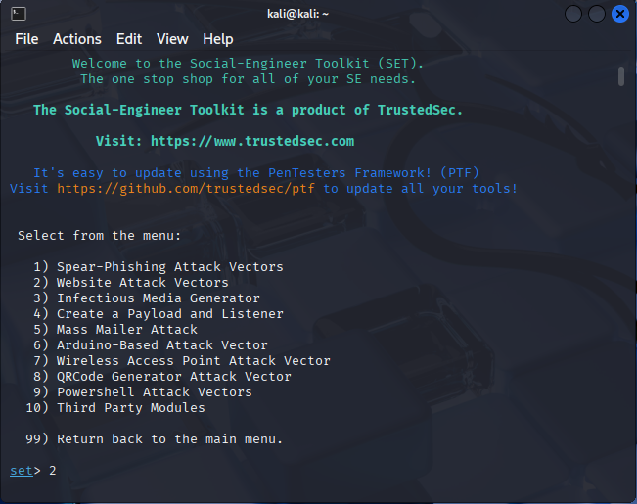

Step 3: Select Credential Harvester Attack Method
- Credential Harvester Attack Method
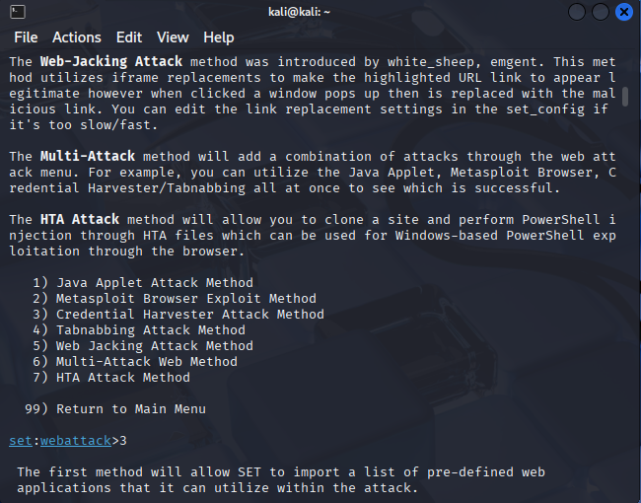

Step 4: Select Site Cloner
- Site Cloner
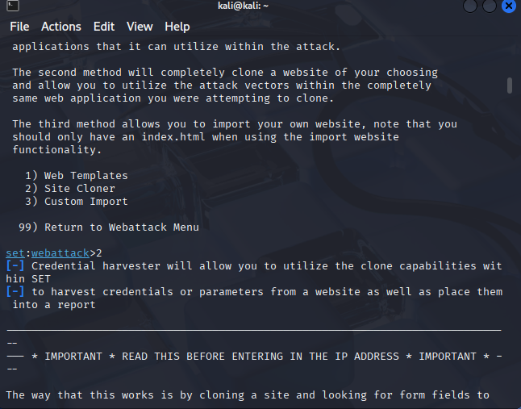

Step 5: Enter Attacker (Kali) IP Address
Find your IP address:
ifconfig
Enter the IP address when prompted.
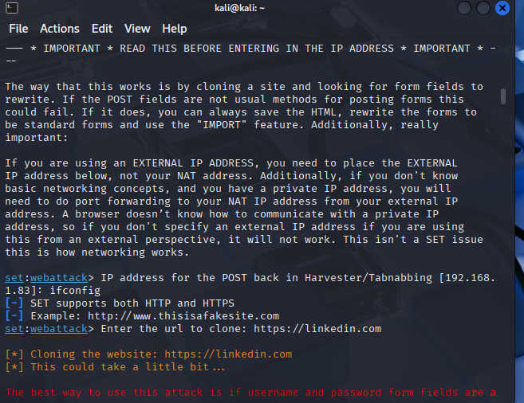

Step 6: Enter Target Website URL
Example:
https://facebook.com
SET will clone the website and host it locally.

📂 Observing the Attack
- The cloned website looks identical to the original
- When a user enters credentials, SET captures them
- Captured credentials appear in the terminal

Sample Output
[*] WE GOT A HIT!
Username: test@gmail.com
Password: 123456
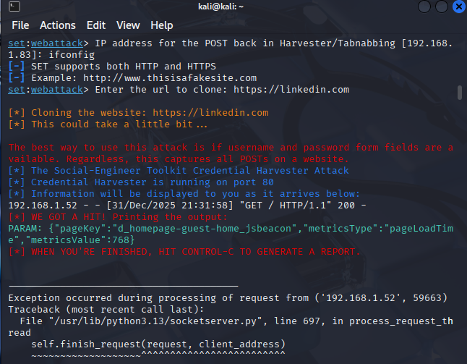

Analysis & Discussion
- The attack succeeds due to visual deception
- No encryption is broken
- The victim willingly provides credentials
- Demonstrates why phishing is effective

🛡️ Security & Defense Measures
Threat | Defensive Measure
Phishing websites | Verify URLs and HTTPS
Credential theft | Multi-Factor Authentication
Fake emails | Email filtering & awareness
USB-based attacks | Disable autorun
Social manipulation | Security awareness training

📊 Result
The lab successfully demonstrated how social engineering attacks exploit human trust and how attackers can harvest credentials using cloned websites.

❓ Viva / Review Questions
- What is social engineering?
- Why is social engineering effective?
- What is credential harvesting?
- Difference between phishing and spear-phishing?
- How can social engineering attacks be prevented?

📝 Conclusion
Social engineering attacks highlight the importance of human awareness in cybersecurity. Tools like SET help security professionals understand attacker techniques and design better defense mechanisms.

End of Lab Manual

